Day in the Life of the Hudson River 10/13/22
Pier 4, Brooklyn Bridge Park, NY
East RIVER MILE: 1.7
Salt Front: ~ 76
Brooklyn Bridge Park Conservancy & Fort Greene Prep Academy– Christina Tobitsch
35 students & 11 adults
Latitude 40.69653°N & Longitude –73.99971°W
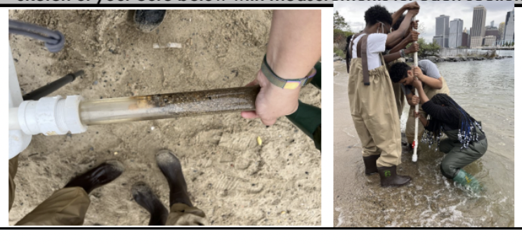
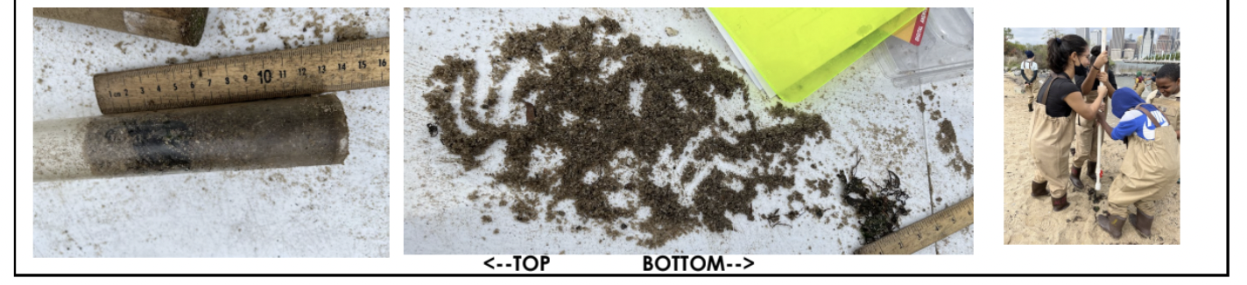

Location: Pier 4 Beach, Brooklyn Bridge Park, East River
Area: Sandy beach peninsula with sheltered coves between Pier 3 and the One15 Marina
Sampling Site: Beach, covered in vegetation, ripraps (large rocks), and pipe entering the water
Surrounding Land Uses: Beach and park
Shoreline: 85% Sandy & 15% Rocky
River Bottom: Sandy
Water: Calm
Plants in the Water: None
*NR = Not read/recorded
ITEM |  | Time |  | Reading |  |  |  | Comments
Physical
Air Temperature- |  | 10:35AM-12:25 PM  12:40 PM |  | 21°C |  |  | 70°F  68°F
Wind Speed: NR |  |  |  | Anemometer |  |  | Beaufort | Direction
Weather today |  | 11:00 AM |  | >75% cloud cover |  |  | Rain began at 12:43 PM; steady rain after 1 PM
Weather the past 3 days: |  | Sunny
Tides- tide stick |  | Time |  | Rising, Falling, Unchanged |  |  | Water Height (cm)
 |  | 10:40 AM-  10:53 AM  11:20 AM  12:00 PM  12:23 PM |  | Rising  Rising  Rising  Falling  Falling |  |  | 19 cm  23 cm  28 cm  20.3 cm  18 cm | HT @ 11:39 AM  *tide stick reset several times as it fell
Current- NR |  | Time |  | Cm/sec |  | Knots | North/South | Ebb/Flood/Still
Water Temperature- |  | 10:20 AM  11:57 AM |  | 19°C  20°C |  |  | 67°F  68°F
Turbidity- Long Sight Tube (120 cm) |  | 12: 58 AM |  | 102 cm
Chemical
Salinity-Hydrometer |  | 10:20 AM  10:45 AM  11:05 AM  11:57 AM  12:15 PM  12:37 PM |  | 27 ppt  26 ppt  26.3 ppt  23.6ppt  24.6 ppt  23.5 ppt
Standardized Salinity – Refractometer |  | 12:07 PM |  | 25 ppt
DO – Color Tablets |  | Time |  | Temp |  |  | ppm DO | % saturation
 |  | 10:20 AM  10:45  11:05  11:57  12:15 PM  12:37 |  | 19°C  20°C |  |  | 7 ppm  6 ppm  8 ppm  7 ppm  7 ppm  6 ppm | NR
pH – Color Match Kit |  | 11:05 AM |  | 7 |  |  |  | *multiple readings 10:20-12:37 PM all between 7 and 7.5
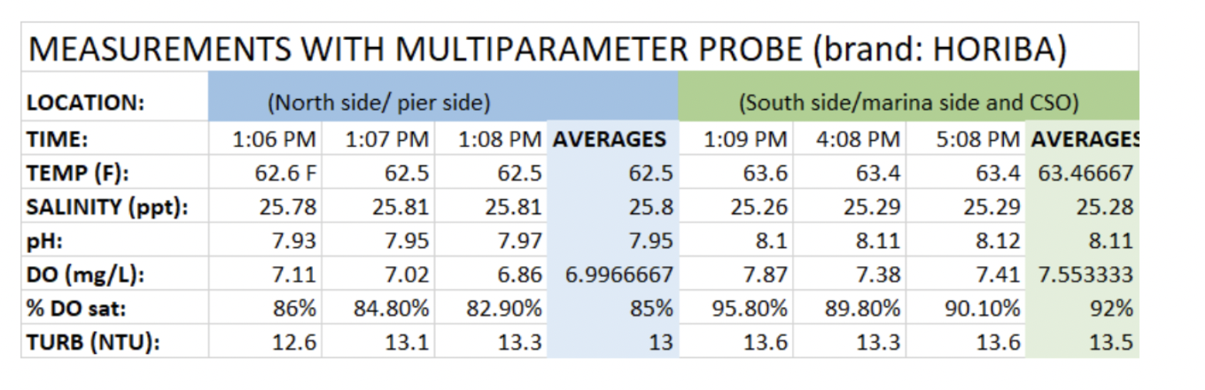
Biological-
Fish – Seine |  | Number |  | Name |  |  | Length of longest | Length of smallest
10:30 AM-12:30 PM |  | 148  131  2  1 |  | Atlantic Menhaden  Atlantic Silverside  Bluefish  Winter Flounder |  |  | 10.5 cm  NR  19.5 cm  8 cm | 7 cm  NR  13 cm  -
Fish Totals |  | TOTAL: 282 |  | Diversity: 4
Macroinvertebrates |  | Number |  | Name |  |  | Length of longest | Length of smallest
 |  | 5 |  | Comb jellies
Macroinvertebrate Totals |  | TOTAL: 5 |  | Diversity: 1
Sediment Core – 10:14 AM, 10:30 AM, 11:10 AM, 12:10 PM & 12:30 PM collection
Length | H2S smell |  | Oxid Top |  | Oil |  | Grain Size | Other Features
10:14 AM 12 cm  10:30 AM 14 cm  11:10 AM 13 cm  12:10 PM 10 cm  12:30 PM 13 cm | No  Yes  No  No  No |  | No  No  No  No  No |  | No  No  No  No  No |  | Abundant: sand  Rare: gravel, pebbles  Abundant: sand  Rare: pebbles  Abundant: sand  Rare: gravel  Abundant: sand  Common: gravel  Rare: pebbles  Abundant: sand  Rare: gravel, pebbles | Rare: oyster/clam shell mix, living vegetation algae  Rare: oyster shells, brick, 1 microplastic  Common: living vegetation algae  Rare: wood, oyster /clam shells  -  Rare: oysters /clam shells, brick
Boats- NR
 | Time |  | Name |  | Color |  | North/Southbound | Light/Loaded
Commercial
Recreational

